

ON-THE-JOB TRAINING REPORT
Development of localised flash flood prediction tool for upper Meghna River basin, Bangladesh
24-28 Jun 2024

Introduction
Floods cause loss of life and massive damage to infrastructure every year, especially in the northeast part of Bangladesh. They also have a significant impact on the country’s economy due to agricultural damage. In 2019, flash floods in the districts of Sylhet and Sunamganj affected over 50,000 people and caused massive damage to crops. Similarly, heavy monsoon rains in 2020 affected 21 districts in the north and northeast parts of the country, impacting over 700,000 families and causing damage to infrastructure and agricultural products). In 2021, Sylhet, Sunamganj, and Habiganj districts were inundated, affecting over 200,000 people.
Given the significant impact of floods, a Flood Early Warning System (FEWS) is crucial as it provides notice of impending floods, giving people precious time to evacuate and take action to save their valuables. The Flood Forecasting and Warning Center (FFWC) under the Bangladesh Water Development Board (BWDB) is the main agency responsible for flood management in Bangladesh. Partnering with the FFWC, we have utilised HIWAT precipitation data to develop a hydrological model for flash flood forecasting in the upper Meghna River Basin. We have employed an open-source J2000 hydrological model, which is expected to provide better flash flood forecasting due to increased resolution compared to the current system at the FFWC.
One key aspect of SERVIR-HKH is the capacity building of its partners in the use of the developed model. As part of this activity, we are organising an on-the-job training for FFWC officers on June 17-21, 2024

Objectives
The training aims to provide participants better understanding of:
- The functionality of the J2000 hydrological model
- Use of HIWAT rainfall to generate flood forecast
- Get feedback to be incorporated into the model

Proceedings
The training was held at the ICIMOD headquarter from June 24 to 28, 2024, with two participants attending the five-day event. The attendees were from the Flood Forecasting and Warning Center (FFWC) and River Morphology Processing Branch (RMPB) of Bangladesh Water Development Board (BWDB) (Annex 2).
During the five-day training the participants were made aware of the existing SERVIR web application such as HIWAT, Flash Flood Prediction Tool (FFPT), Streamflow Prediction Tool (SPT) and Flood Inundation Mapping Tool. These tools are currently running at ICIMOD server and available at both HKH regional level and Bangladesh country level.
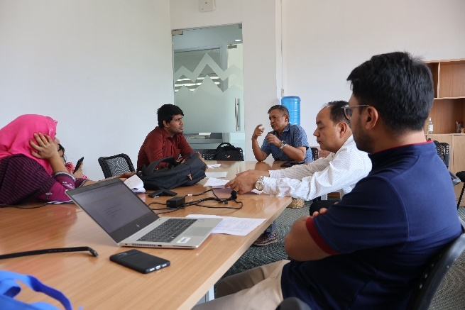 | 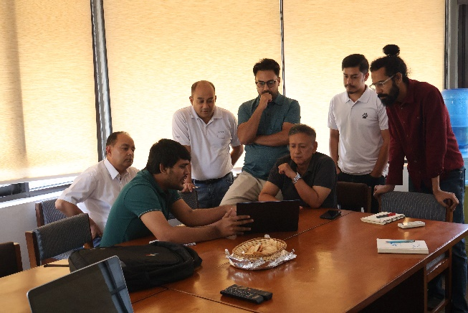
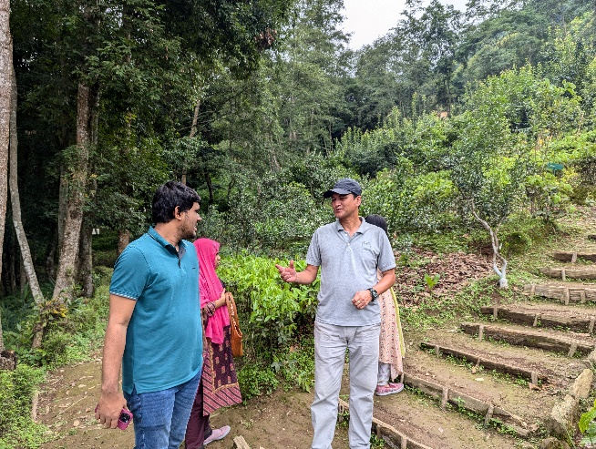 | 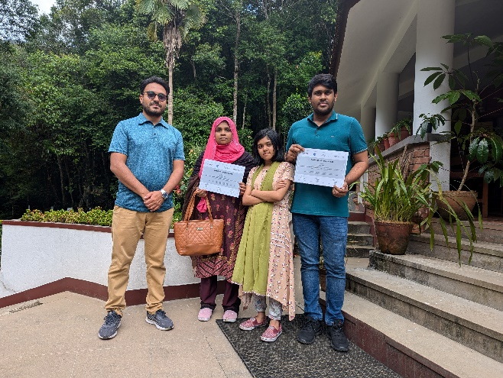
Figure 1: Picture from the training
Installation of the model, running and analysing the results started from second day. The participants during day 2 to day 3, learned how to change the physical parameters and create inputs like meteorology and hydrology data required for the model. They learned different components introduced in the model like bifurcation of river and hoar region. On day 4 they were introduced to the automation process for model run.
On the last day an interactive session was organized with ICIMOD colleagues working in the DRR sector. Participants were introduced on the concept of CBFEWS and were introduced the Bramhaputra River Basin Networks. In the afternoon participants visited the Living Mountain Lab to learn about different solutions for improved agriculture productivity developed by ICIMOD.

Discussion points
- HIWAT system working good at NE Bangladesh.
- FFWC currently has 15 min Realtime WL data in several rivers but is under experiment phase.
- FFWC is interested to run the model developed by ICIMOD and add forecast information in FFWC’s website.
- FFWC have provided few additional data for model calibration/validation.
- FFWC will provide boundary points for discharge forecast.
- Require hydrograph to display forecast with 7 days of hindcast discharge.
- Interest in running all 12-ensemble forecast.
- Requested to help build automatic bulletin for flood forecast system.
- Requested to develop script to run back date (previous forecast).
- Requested to develop script for automatic validation of the model.
- FFWC will deploy the developed model in their workstations at their headquarter. Might require aid from ICIMOD.
- RMPB request for river morphology forecasting. Can explore AI technology.

Training feedback
The post- training questionnaires were distributed, and the participants were approached to fill those for the post- training appraisal. The overall training relevance evaluation (Table 1).

Relevancy of the training and training quality
The evaluation was carried out for five different levels of relevancy and quality from extremely high to not at all (Table 1)
For all the topics of training relevancy and quality, both the OJT participants said that training was highly relevant to their studies and work. An overall, reflection can be observed from the table 1.
- Both the participants responded as yes for enhanced capacity and to apply the knowledge gained.
- Both he participants responded at extremely high and high level respectively for the sessions to be informative and valuable.
Reflections and feedback from the participants
Participants reflected on the training with respect to the asked questions as listed below:
Please comment your experiences on the knowledge and skill-related sessions
- such sessions would be helpful to gather knowledge for those who needs to build up their knowledge related to new model building besides the already established models
How do you plan to use the skill and knowledge from this training in your future work? Please elaborate.
- In developing model for forecasting morphological changes of the river.
- The system will be helpful for our flash flood prediction system
What did you like most about this training? Please elaborate.
- The HIWAT prediction, the model & the automation process
Feedback to the resource person
- Very good and knowledgeable

Agenda
All timestamps are in Nepal Standard Time (NPT)
Day 1 | Monday, 17 June 2024
Time | Topic | Resource person
10:00-10:15 | Introduction and interaction with the participant | All
10:15-10:45 | Overview of SERVIR-HKH services | Birendra Bajracharya, ICIMOD
10:45-11:00 | Tea/Coffee break
11:00-12:30 | Overview of HIWAT | Kiran Shakya, ICIMOD
12:30-13:30 | Lunch break
13:30-14:30 | Overview of Flash Flood Prediction Tool and Streamflow Prediction Tool | Manish Shrestha, ICIMOD
14:30-14:45 | Tea/Coffee break
14:45-16:30 | Overview of J000 model | Manish Shrestha, ICIMOD

Day 2 | Tuesday, 18 June 2024
Time | Topic | Resource person
10:00-11:00 | Installation of the J2000 model | Prabhat Shrestha, ICIMOD
10:00-11:15 | Tea/Coffee break
11:15-12:30 | Hands-on exercise on the J2000 model – physical parameters setup | Manish Shrestha, ICIMOD
12:30-13:30 | Lunch break
13:30-14:30 | Hands-on exercise on the J2000 model – meteorological input setup | Manish Shrestha, ICIMOD
14:30-14:45 | Tea/Coffee break
14:45-16:30 | Hands-on exercise on the J2000 model – running the model | Manish Shrestha, ICIMOD

Day 3 | Wednesday, 19 June 2024
Time | Topic | Resource person
10:00-11:00 | Hands-on exercise on the J2000 model – river bifurcation and hoar region | Manish Shrestha, ICIMOD
10:00-11:15 | Tea/Coffee break
11:15-12:30 | Hands-on exercise on the J2000 model – calibration and validation of the model | Manish Shrestha, ICIMOD
12:30-13:30 | Lunch break
13:30-14:30 | Hands-on exercise on the J2000 model – scenario development | Manish Shrestha, ICIMOD
14:30-14:45 | Tea/Coffee break
14:45-16:30 | Hands-on exercise on the J2000 model – analysing the result | Manish Shrestha, ICIMOD

Day 4 | Thursday, 20 June 2024
Time | Topic | Resource person
10:00-11:00 | Reflection and Q & A | All
10:00-11:15 | Tea/Coffee break
11:15-12:30 | Hands-on exercise – Automation process of the model run | Prabhat Shrestha, ICIMOD
12:30-13:30 | Lunch break
13:30-14:30 | Hands-on exercise – Automation process of the model run | Prabhat Shrestha, ICIMOD
14:30-14:45 | Tea/Coffee break
14:45-15:00 | Closing remarks | Birendra Bajracharya, ICIMOD

Day 5 | Friday, 21 Jun 2024
Time | Topic | Resource person
10:00-12:30 | Interaction with ICIMOD colleagues working in the Disaster Risk Reduction sector | All
12:30-14:00 | Lunch break
14:00 onwards | Visit to Living Mountain Lab | All

Annex 2: List of participants
S No. | Name | Sex | Organization | Position | Email
1 | Mehadi Hasan | M | Flood Forecasting and Warning Center | Assistant Engineer | hasanmehadi875@gmail.com
2 | Riffat Sharmin | F | River Morphology Processing Branch | Executive Engineer | riffatbwdb@gmail.com

