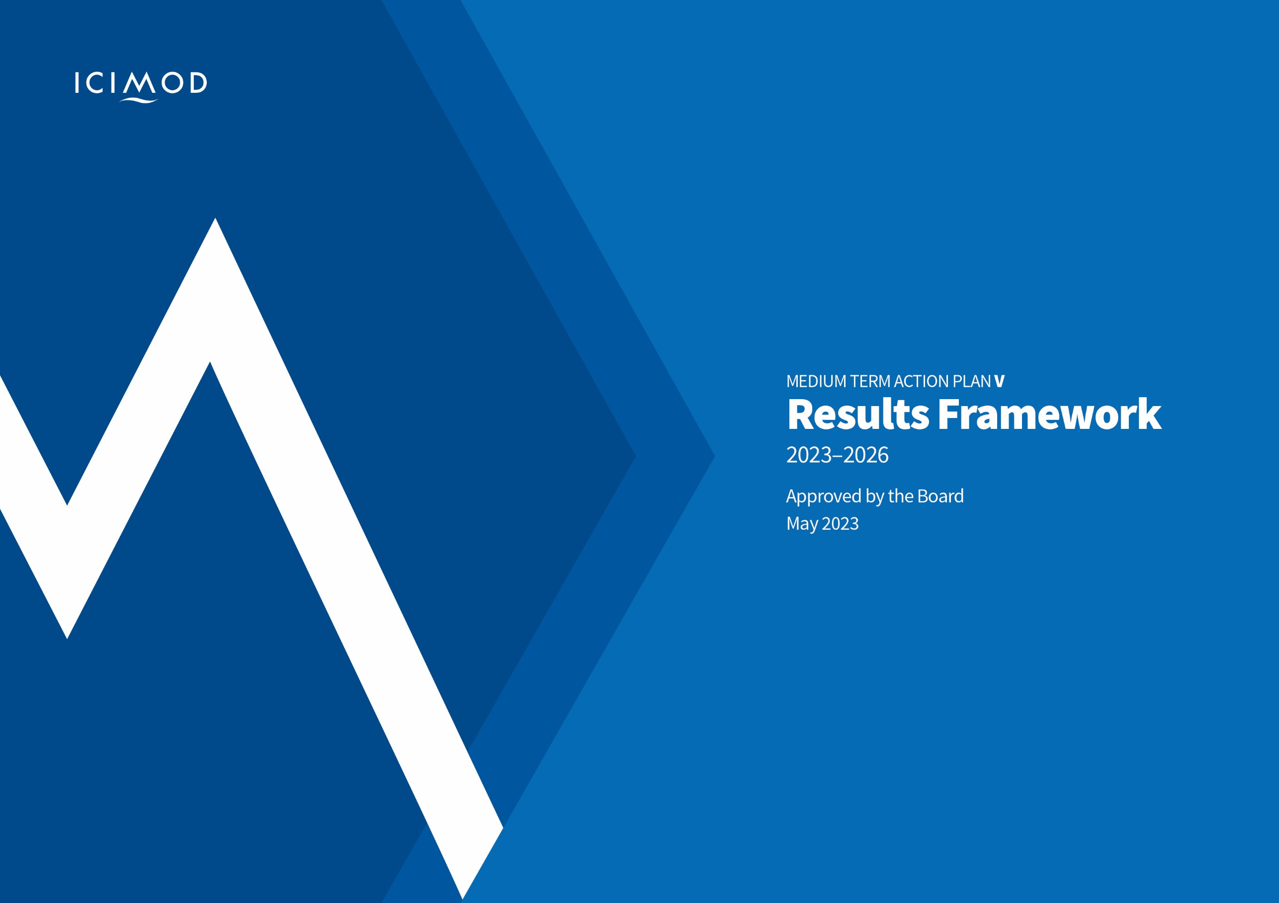
NOTE:
The original one was approved by the Board and have been updated in the middle of the MTAP cycle. The Nomenclatures has also been updated
Result Framework (RF)
Medium Term Action Plan (MTAP) V 2023-2026:
Embracing Change and Accelerating Action

Version Control
The original RF was approved by the Board in May 2023. The current version has been updated in December 2024 based on the two years of experience and learning.
Introduction
This Results Framework supports the delivery of the Strategy 2030: Moving Mountains and MTAP V (2023-26). It articulates what results we will achieve in response to the ambitions laid out in the institutional Theory of Change of our Strategy 2030. As laid out in these documents, we are now moving towards an adaptive, learning and performance-based approach to tracking our results. This will require placing much greater focus on assessing collective impact and outcomes delivered from across our entire portfolio, and in collaboration with partners, in what is a complex and shifting regional environment.
Approach
We have three levels of results as defined in the Strategy 2030: long-term impact areas (LTIAs), high-level outcomes (HLOs) and specific outcomes (SOs). This document lays out the steps we will take to achieve our SOs up to 2026. It is important to read this document with the recognition that, in most areas of work, to achieve the specific outcomes, more work will be needed during MTAP VI (2027-2030), i.e. during MTAP V we will not have achieved all elements required to deliver the specific outcomes, but by 2026 will aim to be at an intermediate stage, such as having built capacity or promoted better policies or improved collaboration. By 2030 we will have further expanded on our specific outcomes. Clearly, a critical question is whether all this will result in improved livelihoods, saved lives, a cleaner environment etc over the years that follow. ICIMOD will be tracking key areas of impact, and assessing ICIMOD’s contribution to these, as set out in the forthcoming Monitoring Evaluation and Learning (MEL) plan (see below).
A set of intensive and iterative results planning sessions, with ICIMOD’s new Action Area teams, led to the compilation of this Results Framework. This work completes the second stage of our transition (as articulated in the Planning for Results Section 2.2.2 of MTAP V). It lays out our detailed results commitments against the MTAP V Specific Outcomes, which are delivered through a set of Interventions that are housed within our six Action Areas (see Table 1 below).
The process of putting this Result Framework together, has sought to build ownership and capability for results planning amongst our staff and partners, and as we move forwards, we will continue to strengthen results planning, tracking and monitoring capabilities, including being far more cognisant of actions by partners that are relevant to our own results. We will hold reflection and learning sessions, in line with our Strategy 2030 and MTAP V commitments to adaptive management, that will investigate progress against outcome targets and make practical decisions about specific Interventions to progress, amplify, put on hold or stop.
The current draft Results Framework is a firm commitment to what we intend to achieve but, given the rapid pace and enormity of tasks required of our transition, we do expect some further tightening and narrowing of our commitments, especially to ensure that the 2026 targets are realistic and measurable, and ensuring our outer year milestones adequately reflect progress to outcome but also because scoping studies are planned for newer areas of work, which help define specifics of work. As our understanding of context and RMC needs and priorities deepens, and as we deepen our learning through the annual review, whilst we will not make major changes to our commitments, some further fine tuning will be needed. The Monitoring and Evaluation Framework (see below) that will be developed in the latter part of 2023 will further articulate how we will measure progress against our results commitments.
A Guide to the Results Framework
The results are laid out for each Intervention below (note some Intervention titles may still be tightened). Each Intervention has its own separate results framework table. Each table identifies specific desired changes in policy, capacity, innovation and/or scaling, and regional collaboration, that lie within ICIMOD’s sphere of influence, couched as Specific Outcomes and 2026 Targets (Columns 1 and 2). It then identifies the baseline situation (Column 3), and key milestones on the way to achieving the Specific Outcomes (Column 4). A key set of expected and significant outputs is listed in Column 5.
MTAP Specific Outcomes
Specific desired changes expected at the end of MTAP V period. These are changes that are expected in policy, capacity, scaling, and/or regional collaboration.
MTAP Specific Outcome Targets
These targets include both qualitative and quantitative elements of what we expect to have achieved against the corresponding baseline situation.
Baseline Situation 2022
Baseline is defined at the current situation in HKH region and describes what is going on in terms of context, challenges, policies, capacities, and collaboration.
Key Milestones for Specific Outcome 2026 targets
Key milestones are key steps and movements in our journey towards achieving our specific outcome 2026 targets. It is important to note that first two years it is inevitable that there will be milestones more within our sphere of control, e.g. tangible products and services. However, as we move on to 2025 and 2026, the key milestones will move more towards our sphere of influence, and thus features achievements that are closer to specific outcomes, and 2026 targets.
Key Outputs
These are generic expected major outputs defined for the MTAP V period. These are shorter-term results contributing to key milestones and achievement of specific outcome targets.
Next steps in developing the Monitoring, Evaluation and Learning (MEL) System
During 2023, ICIMOD will continue working to strengthen our results processes and systems further, as per the commitments in Annex 3.1 of MTAP V, including:
- Developing a detailed MEL framework that which will further elaborate on our overall MEL approach. The framework will detail our indicators, GESI Markers and define how we will track our contributions to high-level outcomes and long-term impact areas. The MEL framework will also include the detailed process we will undertake for implementing the ’Stages to Outcome’ approach, which will help demonstrate how we make progress against our interventions’ specific outcomes. It will also outline how we will monitor and report cross cutting issues: Gender and Social Inclusion, Climate Change and Biodiversity, using OECD markers, where relevant.

- As part of the MEL framework, we will also develop specific MEL plan for each Intervention which will set out roles and responsibilities for data collection and reporting and specific data to be collected. Each Intervention’s MEL plan will have clear mechanisms and responsibilities defined for tracking and reporting against Strategy 2030 high-level outcomes (HLOs) and long-term impact areas (LTIAs).
- Embarking on the development of an online Results Dashboard (from second half 2023) which will provide publicly accessible information on our progress against SOs, HLOs and LTIAs.
- Looking at options for strengthening our internal Management Information System (MIS) to ensure it is linked with our finance and performance management systems.
- Conducting regular internal SG and AA level reviews that reflect on evidence of progress and feed decisions on whether to amplify, continue, hold, or reorient, stop (ACHoRS exercises). The first ACHORS review will be in late 2023. This should be as far as possible done with partners.
- Strengthening our evaluation and impact assessment functions (from second half 2023).
- Initiate development of a means of institutional performance tracking through formulation of a set of KPIs for our organisation, in line with Strategy 2030 Strategic Objective 4.

Table 1: Interventions by Action Area and Strategic Group
Strategic Group (SG) | Action Area (AA) | Intervention
Strategic Group  Climate and Environmental Risks | Action Area  Cryosphere and Water | Intervention: 1  Cryosphere
Strategic Group  Climate and Environmental Risks | Action Area  Cryosphere and Water | Intervention: 2  DRR
Strategic Group  Climate and Environmental Risks | Action Area  Cryosphere and Water | Intervention: 3  River Basins
Strategic Group  Climate and Environmental Risks | Action Area  Air | Intervention: 1  Air Quality Monitoring
Strategic Group  Climate and Environmental Risks | Action Area  Air | Intervention: 2  Air Pollution Mitigation
Strategic Group  Resilient Economies and Landscapes | Action Area  Economies | Intervention: 1  Foresight
Strategic Group  Resilient Economies and Landscapes | Action Area  Economies | Intervention: 2  Livelihoods and Enterprises
Strategic Group  Resilient Economies and Landscapes | Action Area  Economies | Intervention: 3  Settlements
Strategic Group  Resilient Economies and Landscapes | Action Area  Economies | Intervention: 4  Renewable Energy
Strategic Group  Resilient Economies and Landscapes | Action Area  Landscapes | Intervention: 1  Springs
Strategic Group  Resilient Economies and Landscapes | Action Area  Landscapes | Intervention: 2  Rangelands and Wetlands
Strategic Group  Resilient Economies and Landscapes | Action Area  Landscapes | Intervention: 3  Incentives
Strategic Group  Resilient Economies and Landscapes | Action Area  Landscapes | Intervention: 4  Human-wildlife coexistence
Strategic Group  Regional Action and Global Advocacy | Action Area E  Regional | Intervention: AAE 1  Regional cooperation and collaboration mechanisms
Strategic Group  Regional Action and Global Advocacy | Action Area E  Regional | Intervention: AAE 2  Regional Information Service
Strategic Group  Regional Action and Global Advocacy | Action Area E  Regional | Intervention: AAE3  Regional Networks
Strategic Group  Regional Action and Global Advocacy | Action Area F  Global | Intervention: AAF 1  Global Engagement
Strategic Group  Regional Action and Global Advocacy | Action Area F  Global | Intervention: AAF 2  Leveraging investment

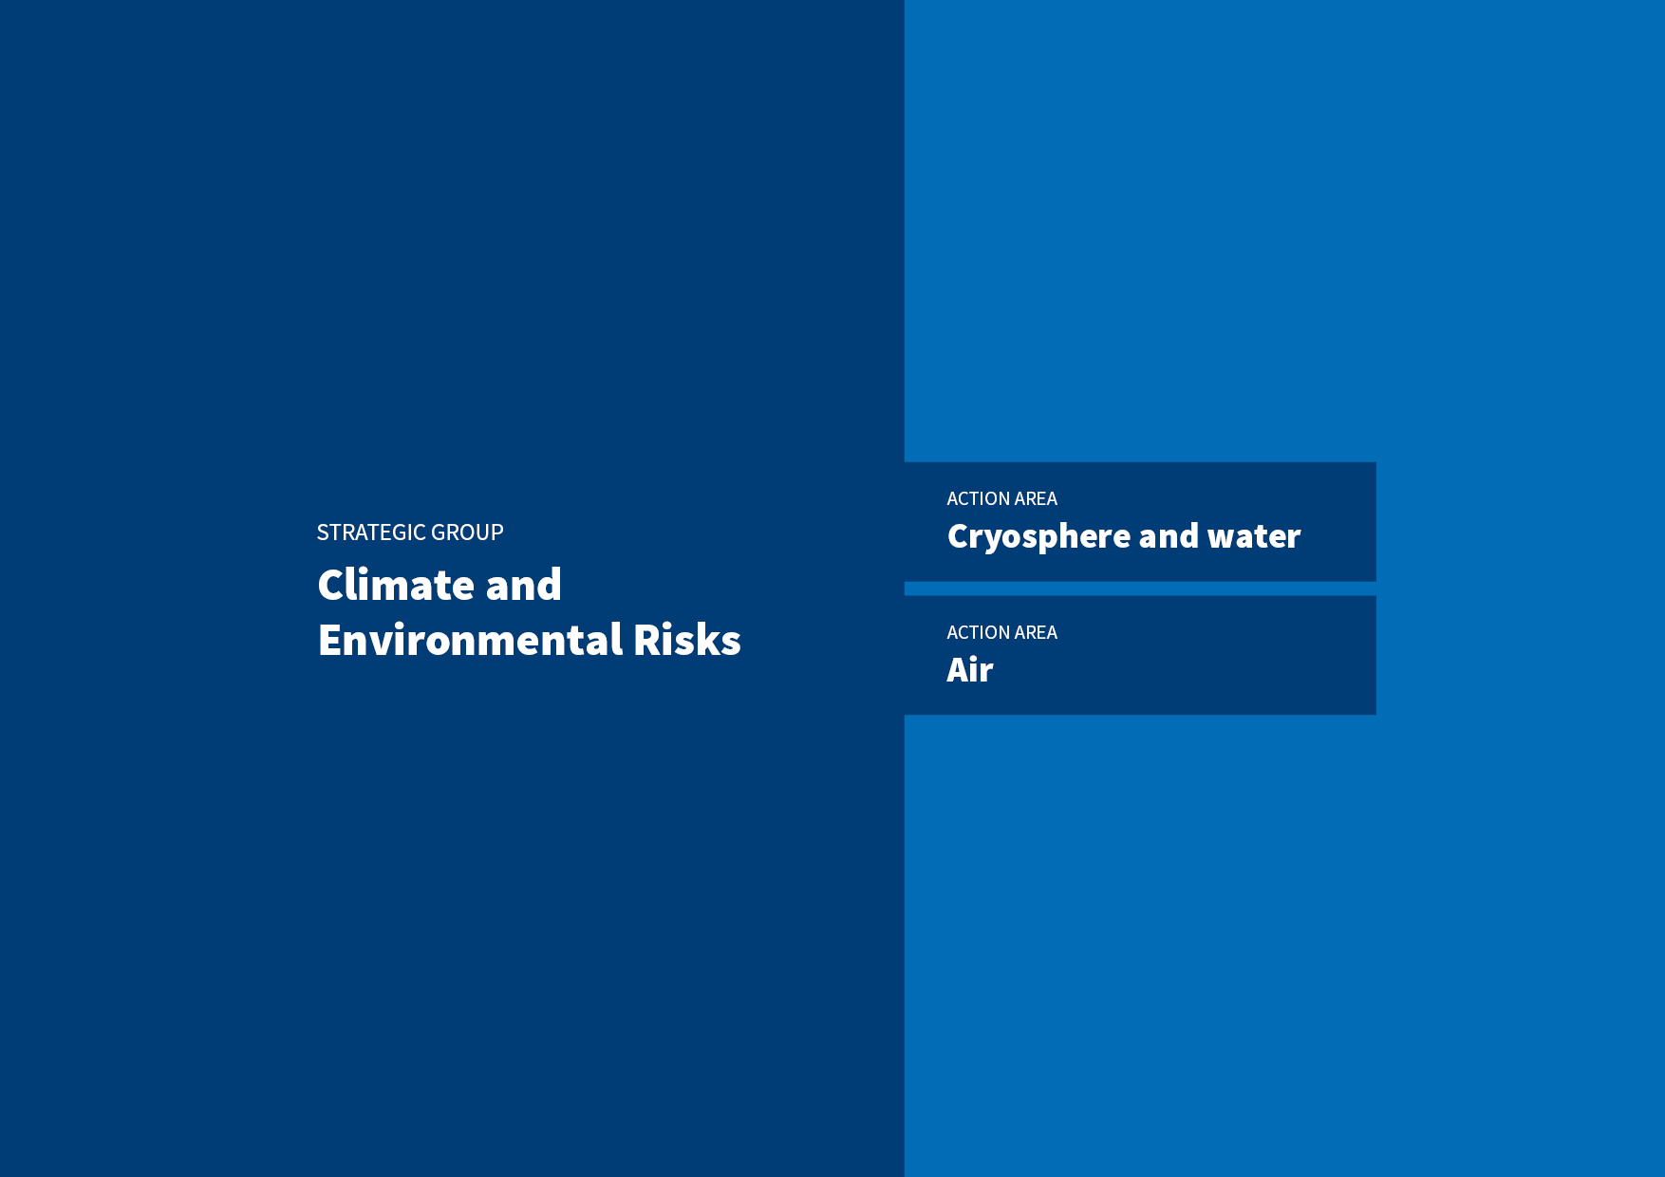

ACTION AREA
Cryosphere and Water

INTERVENTION 1
Cryosphere
MTAP Specific Outcomes | MTAP Outcome targets 2026 | Baseline Situation 2022 | Key milestones for Specific Outcome targets till 2026 | Key Outputs
Improved capabilities of RMC institutions to monitor cryosphere in systematic and effective ways for risk management, especially in face of climate change | At least three RMCs are capable of independently operating cryosphere monitoring systems generating quality data and analyses and using results for decision making. | Four of the six RMCs lack the required capability to independently operate and generate comprehensive data.  Significant data gaps on cryosphere status, projected changes, and related hazards, which are partly due to a lack of analytical capabilities across the HKH resulting in insufficient information for decision makers to respond effectively to cryosphere hazards, as well as very little cross HKH coordination | 2023: Relevant institutions from three RMCs agree to significant steps towards more comprehensive and coordinated cryosphere observation and risk analysis (e.g. Nepal and Pakistan – glaciers, snow, permafrost; Bhutan – snow and permafrost).  2023: High Mountain Asia (HKH++) GLOF database and dashboard used by relevant institutions for informed decision-making to reduce GLOF risks.  2024: Two RMC institutions initiate their own cryosphere monitoring and use the results of the data and analyses for decision-making  2025: Three RMC key institutions initiate their own cryosphere monitoring and risk analysis.  2026: Key institutions in three RMCs using cryosphere analysis for informed decision making and risk management while operate cryosphere monitoring systems independently | A holistic capability assessment conducted (studying existing capacity, conditions, structures, including for the delivery of more effective cryosphere monitoring) in RMCs.  Training and workshops conducted to promote the use of cryosphere data and improve knowledge and skills on cryosphere observations, analyses and risk management.
RMCs adopt systematic and harmonized approaches for effectively responding to changes in cryosphere through stronger coordination, engagement, and communication across the HKH and internationally | 5 RMCs with substantial cryosphere coverage actively engage in region-wide syntheses of cryosphere regional and global fora. | Analytical capabilities remain lacking at regional level and there is a limited regional exchange of information, despite several site-specific studies. There is also little communication and engagement on the diverse implications of changes either regionally or internationally. | 2023: Initiation of cryosphere regional syntheses through working groups  2024: At least one regional synthesis published  2025: A cross-regional permafrost/cryosphere monitoring and risk analysis strategy put into practice by relevant partners.  2025: Findings of comprehensive analysis of cryosphere impacts used by RMCs and globally.  2026: Cross regional strategy implemented with the support of 5 RMCs. | Regional working groups established on cryosphere topics under HKH CryoHub.  An approach to developing a regional cryosphere strategy co-created including literature review, dialogues with government line agencies and other relevant institutions working on cryosphere in the HKH, and a stakeholder analysis.  A comprehensive analysis of cryosphere impacts carried out including linkages to ecosystems and society in the HKH.
INTERVENTION 2
DRR
MTAP Specific Outcomes | MTAP Outcome targets 2026 | Baseline Situation 2022 | Key milestones for Specific Outcome targets till 2026 | Key Outputs
DRR national policies and strategies in relevant RMCs influenced to integrate mountain specific hazards, including multi-hazard risk management approaches. | At least three national DRR authorities are addressing mountain specific hazards through their policies and strategies. | Mountain specific hazards are not being given the necessary attention. And yet they are more complex and inter-related in nature. There is some awareness of the need for multi-hazard approaches, but these are complex to implement.  Emerging hazards from climate change are not always included and are increasing in complexity. There is also a rapidly increasing risk from landslides and soil erosion, and worsening risks associated with too much and too little water. | 2023: Multi-hazard risk assessment (MHRA) framework with specific focus on cascading mountain hazards co-created with key RMC stakeholders.  2023: Capacity gaps of local line agencies in the Lower Koshi River Basin (LKRB) on GEDSI responsive DRR and watershed development co-identified, and response plans co-developed.  2024: GEDSI responsive DRR processes documented and made available.  2024: Multi-hazard risk assessment (MHRA) framework with specific focus on cascading mountain hazards co-created with key RMC stakeholders  2024 and 2025: Mountain-specific DRR approaches initiated in two RMCs, including MHRA approaches.  2025: Local governments in Lower Koshi River Basin (LKRB) are capacitated to integrate GEDSI responsive DRR and watershed planning, management, budgeting, and monitoring.  2026: At least one municipality in LKRB adopts GEDSI integrated DRR planning, management and budgeting and one additional municipality integrates DRR planning, management and budgeting.  2026: At least one RMC integrates mountain specific DRR approaches, including MHRA, within their DRR policies, regulations and/or guidelines | Policy reviews and gap analysis co-produced of how RMCs are addressing mountains hazards and in particular multi-hazards.  Government agencies supported integrating GESI responsive DRR approaches in their plans.  GESI responsive DRR trainings and workshops conducted based on needs assessment.  Lessons learnt on disaster preparedness shared using platforms like KDKH.
Institutional mechanisms strengthened at regional and national levels for disaster risk reduction, preparedness and resilience building in the context of impact of climate change and biodiversity loss | One regional DRR mechanism functional and bring about improving in reducing disasters | DRR for mountain areas has received little attention, despite mountain hazards having regional and widespread implications.  There are a few regional dialogues ongoing (e.g. Koshi Disaster Knowledge Hub and the Upper Indus Bain Network, that have worked to promote action on ecosystem management in transboundary landscapes and transboundary river basin management. | 2023: All RMCs agree to be part of an HKH-DRR hub.  2024: HKH-DRR knowledge hub organised to work on a regional DRR road map.  2024: Scoping study of financial mechanisms available for disaster risk reduction.  2025: HKH-DRR Knowledge Hub functional discussing issues solutions and risk financing opportunities related to transboundary DRR.  2026: HKH-DRR Knowledge Hub agree on a regional DRR HKH programme proposal or protocol (link to SG3) that has clear value for regional DRR. | Annual dialogues organised (KDKH in 2023 and HKH-DRR hub dialogues in subsequent years)  Consultation workshops organised on gender responsive institutional mechanisms needed to support frameworks for regional cooperation on DRR in 3 RMCs
Wider adoption of GESI responsive and innovative systems and solutions for building resilience against disasters by government, NGOs and other organisations | At least 3 RMCs’ relevant government institutions initiate action on GESI responsive and innovative DRR systems and solutions. | Some forecasting tools are available and forecasts available but still lacking in accuracy and there is still a lack of analysis of what the implications of these forecasts mean for different sectors (i.e. agriculture, water, infrastructure, tourism etc.).  There are still many parts of the HKH where early warning information is not available, given the unique geography of mountain regions. Tools available are not suitable for mountain early warning systems.  There is growing understanding of what measures are needed to improve resilience to disasters, but implementation of resilience measures is lacking. | 2023: Assessment of potential for piloting CBFEWS in Bhutan and Bangladesh.  2023: Co-design of key GESI responsive DRR nature-based solutions (NbS) and watershed related solutions initiated.  2023 Develop and deploy a localized flash flood and landslide mapping and forecasting system in Bangladesh and Nepal  2024: Assessment of potential for piloting Community-Based Flood Early Warning Systems (CBFEWS) in Bhutan and Bangladesh  2024: Partners in Bangladesh and Bhutan capacitated and implementation of CBFEWS initiated.  2024: Effective management of the DRR intervention  2024: Innovative systems like High-Impact Weather Assessment Toolkit (HIWAT) and flood forecasting system implemented in three RMCs.  2024 and 2025: Designed solutions are piloted.  2024 - 2025: Assessment conducted of potential scalable solutions.  2025: CBFEWS piloted and evaluated in Bangladesh and Bhutan ready for scaling.  2025: Framework on key DRR and NbS developed, tested, and implemented.  2025: GEDSI responsive NbS for DRR solutions are piloted along with enhanced capacity of communities to support the testing of GEDSI responsive solutions.  2025: Capacity enhancement of local government officials to implement GESI responsive and innovative GEDSI responsive DRR solutions.  2025: 2 RMCs initiate process to use climate risk management/ hydro-climatic forecasting services for its use in anticipatory actions, including those related to agriculture sector like drought monitoring and outlook system and yield assessments, flood forecasting, and landslide hazard assessment.  2026: Bhutan and Bangladesh integrate CBFEWS into their local planning and budget processes.  2026: At least in one RMC partners embarking on scale up of DRR solutions.  2026: At least two national DRR authorities use ICIMOD-influenced GESI responsive DRR approaches solutions  2026: Quantitative methods on crop mapping and damage assessment as part of the L&D framework along with documenting process undertaken for initiating the use of other hydro-climatic forecasting services.  2026: Policy recommendations based on key findings from the testing and implementation phases communicated with relevant policy and decision makers. | Piloting and testing of CBFEWS in Bangladesh and Bhutan for scaling readiness.  (Nepal) Capacities of the private sector and other organisations built on DRR collaboration.
DRR and watershed solutions in the Lower Koshi Basin codesigned, co-implemented and made ready for scaling.
Local innovations on DRR risks at national and regional levels promoted (with support from other Action Areas).

DRR training of relevant organisations in Bangladesh, Nepal, and Pakistan.
User engagement and piloting services organised as part of co-development process with national agencies in 3 RMCs.
EWS Strategic Action Plan developed for Sudurpaschim (Far-west) province of Nepal.
Services and GIT operations developed with 3 RMCs.
Capacities built of national stakeholders on landslide mapping and forecasting system. (Nepal)
NbS based DRR solutions developed that can address multi hazards and their cascading impacts
Capacities built of communities, government representatives and other stakeholders.
Policy recommendations prepared and shared based on findings from the solutions.

INTERVENTION 3
River Basins
MTAP Specific Outcomes | MTAP Outcome targets 2026 | Baseline Situation 2022 | Key milestones for Specific Outcome targets till 2026 | Key outputs
Enhanced capacity of RMCs in (transboundary) river basin level planning and management | At least three RMCs initiate river basin level planning with special emphasis on increased collaboration and climate risks.  (Includes the Indus, Koshi and Brahmaputra River basins) | Planning based on basin and sub-basin level scenarios using science based modelling, data analytics, and hydro-economic analysis are lacking (ADPC, 2021; HKH country consultations).  Opportunities for collaborative development of basins with intersectoral nexus and upstream-downstream linkage opportunities poorly explored, although there could be tremendous potentials (Scott et al., 2019). | 2023: Networks and other platforms redesigned to focus on cooperative mechanisms for upstream and downstream (US/DS) linkages and integrated management of river basins.  2024: Framework on key DRR and NbS developed, tested, and implementedFramework on key DRR and NbS developed, tested, and implemented  2025: Co-develop River basin management frameworks in the HKH context capturing climate risks.  2025: New Brahmaputra Basin knowledge network (GESI responsive) conceptualized.  2026: Regional policy dialogues deliver high level recommendations for co-operation on river basin management. | Networks and associated platforms restructured, including focus on up and downstream linkages and integration of GESI considerations with stakeholders of the UIBN, KDKH, CryoHub, DRR-Hub  Science-policy-practice interface dialogues organised on river basin management.  Policy recommendations made available on upstream and downstream linkages and action plans
Improved institutional capabilities in using earth observation technologies and innovative IRBM approaches for basin planning. | At least 3 RMCs use of use earth observation, climate models, digital technology and modern IRBM approaches for basin scale planning and climate risk management. | RMCs seek deeper understanding on opportunities for upstream-downstream and risk reductions (National Water Policy of Pakistan (2018); National Climate Change Policy of Pakistan (  Increasing capacity in RMC in earth observation, high performance computing and digital technologies (Country consultations) | 2023: Stakeholders mapping, and partnerships formalized  2024: Co-development of framework (e.g. WEFE etc.) for river basin resource and climate risk assessment with three RMCs  2025: Three RMCs co-testing and applying the framework  2026: Three RMCs integrate climate risk management into river basin management plans | Framework for river basin resource and climate risk assessment co-developed  River basin resource and risks assessment conducted.  Jointly policy reviews conducted in context of water and climate scenarios in the key river basin/sub-basins.  Assessment conducted of water related policies and mechanisms to identify GESI issues in the key river basins
 |  | RMC capacities in earth observation are improved, but still lag behind other regions. There is little capacity for deployment of high-performance computing and other emerging digital technologies. | 2023: Revised resource book on IRBM developed (GESI responsive).  2024: Specialized training module developed on use of earth observation and big data analytics for sustainability and water risk assessment at basin scale.  2024: Yearly training sessions aimed at improving capacity of key stakeholders in basin planning (2025-2026)  2025: Trained professionals from three RMC institutions, facilitating the utilization of learned knowledge.  2026: Basin scale plans and climate risk management framework in 2 RMCs clearly indicate use of ICIMOD inputs. | IRBM Resource Book updated and revised.  Training modules developed on use of earth observation for sustainability and water risk assessment.  Training courses conducted and followed up with relevant organisations

ACTION AREA
Air
INTERVENTION 1
Air Quality Monitoring
MTAP Specific Outcomes | MTAP Outcome targets 2026 | Baseline Situation 2022 | Key milestones for Specific Outcome targets till 2026 | Key Outputs
Decision makers at various levels have capability to use high quality data, tools and evidence on air quality trends and impacts. | At least 3 RMC governments and other decision-makers prioritising national actions for improving air quality environmental, climate and health outcomes. (Bangladesh, Bhutan, Nepal and Pakistan)  At least 3 RMCs adopt and agree on regional harmonised approaches for monitoring regional air pollution | Regional and country-specific air quality and emissions dashboards for RMCs with existing global emission inventory data and models are being established by ICIMOD and partners.  Limited capability among the national and regional institutions to have regionally harmonized approach that reduces air pollution/ air quality management. Recently conducted SPD with WB highlighted the need for regional harmonization | 2023: Partnerships identified and established to set up reviews of current investment levels on air quality, potential solutions, and opportunities for emissions reduction  2023: National and global partners identified (all RMCs) and partnership initiated for energy and emissions information system (in at least 3 RMCs)  2024: At least 3 RMCs regularly communicating with ICIMOD for AQ observatory and or data analysis support  2024 : Innovative new products integrated to regional AQ dashboard and national AQ dashboards functional in at least 3 RMCs.  2024: Availability and accessibility of new data, evidence, and synthesis from ICIMOD to support policy actions in at least 3 countries.  2024: Needs assessment and baselines established for energy and emission information for at least 3 RMCs  2024: 1st version bottom-up emissions and energy estimates for Bhutan and Nepal  completed.  2024: Scoping and need assessment carried out on regional harmonization approaches  2024: At least one relevant science policy dialogue process organized on air quality.  2024: Continued technical training organized to enhance capability of 3 RMC partners for regional air quality monitoring.  2025: Ensured timely and accessible data, evidence, and synthesis from ICIMOD to aid policy actions in at least 3 RMCs  2025: At least 3 RMCs capacitated to understand and incorporate regional harmonization aspects (measurement protocols and standards, data & modelling assumptions/ assessments, media communication and abatement policies, health impact methodology, etc.)  2025: 1st version bottom-up emissions and energy estimates for Bangladesh and Pakistan completed.  2026: At least 3 RMCs are regularly using high-quality data and evidence from the platforms/syntheses for national action to improve air quality  2026: Targeted 3 RMCs adopt and agree on regional harmonised approach for monitoring regional air pollution. | One regional and three national air quality dashboards made functional
 |  |  |  | Innovative earth observation systems tools delivered for air quality monitoring.
 |  |  |  | Demand-driven support provided to partner institutes including In-situ measurements, field campaigns and high-quality, GESI-sensitive syntheses and knowledge products
Operational regional energy balance dashboard
Technical assistance services provided to RMCs for needs assessment, baselines and GESI-sensitive national plans for energy and emissions information
Scoping/needs assessment report made available.
Meeting reports made available for identifying key harmonization aims.

Training courses and technical assistance provided building regional harmonization.

INTERVENTION 2
Air Pollution Mitigation
MTAP Specific Outcomes | MTAP Outcome targets 2026 | Baseline Situation 2022 | Key milestones for Specific Outcome targets till 2026 | Key Output Targets
Accelerated investment in key polluting and GHG-producing sectors in the region based on high-quality evidence and updated knowledge. | At least 4 government institutions and 2 private sector organisations from targeted RMCs (Bhutan, Bangladesh, India, Nepal and Pakistan) allocate budget resources and invest on scaling ups low GHG, clean, energy efficient, and gender responsive solutions using high-quality evidence | Inadequate knowledge of emissions and emission factors from different sources that impact both climate and air quality for scaling up in climate change policies and financing.  Inadequate knowledge of current levels of investments to tackle emissions in different sectors affecting HKH. | 2023: Partnerships established to set up reviews of current investment levels on air quality, potential solutions, and opportunities for emissions reduction  2024: Reviews on current investment levels on AQ, potential solutions, and opportunities for emissions reduction finalized  2024: (Carry forward from 2023)Partnerships established to set up reviews of current investment levels on AQ, potential solutions and opportunities for emissions reductions  2024-2025: Assessment of 3 solutions (based on technological, economical, GESI, policy, etc. aspects) to be promoted for scaling up in 3 RMCs  2025: Development of an assessment modelling chain across HKH to assess emission mitigation strategies for air pollution. (This will support the outcomes of the science-policy dialogue (SPD) organized by ICIMOD which aims at developing harmonized regional approaches. )  2025: Task force of experts on solutions formed to promote investment on scaling up low GHG (including SLCF), clean, energy efficient, and GESI responsive solutions  2026: At least 3 RMCs including private organisations invest on scaling ups low GHG, clean, energy efficient, and gender responsive solutions using high-quality evidence | Review conducted of existing air quality investment in HKH region and relevant source regions.  Review of potential solutions made available for emissions reduction, including assessment of marginal abatement costs, and GESI aspects (including localized monitoring of emissions)  At least one opportunity identified for specific piloting and investment (sector or pollutant specific)

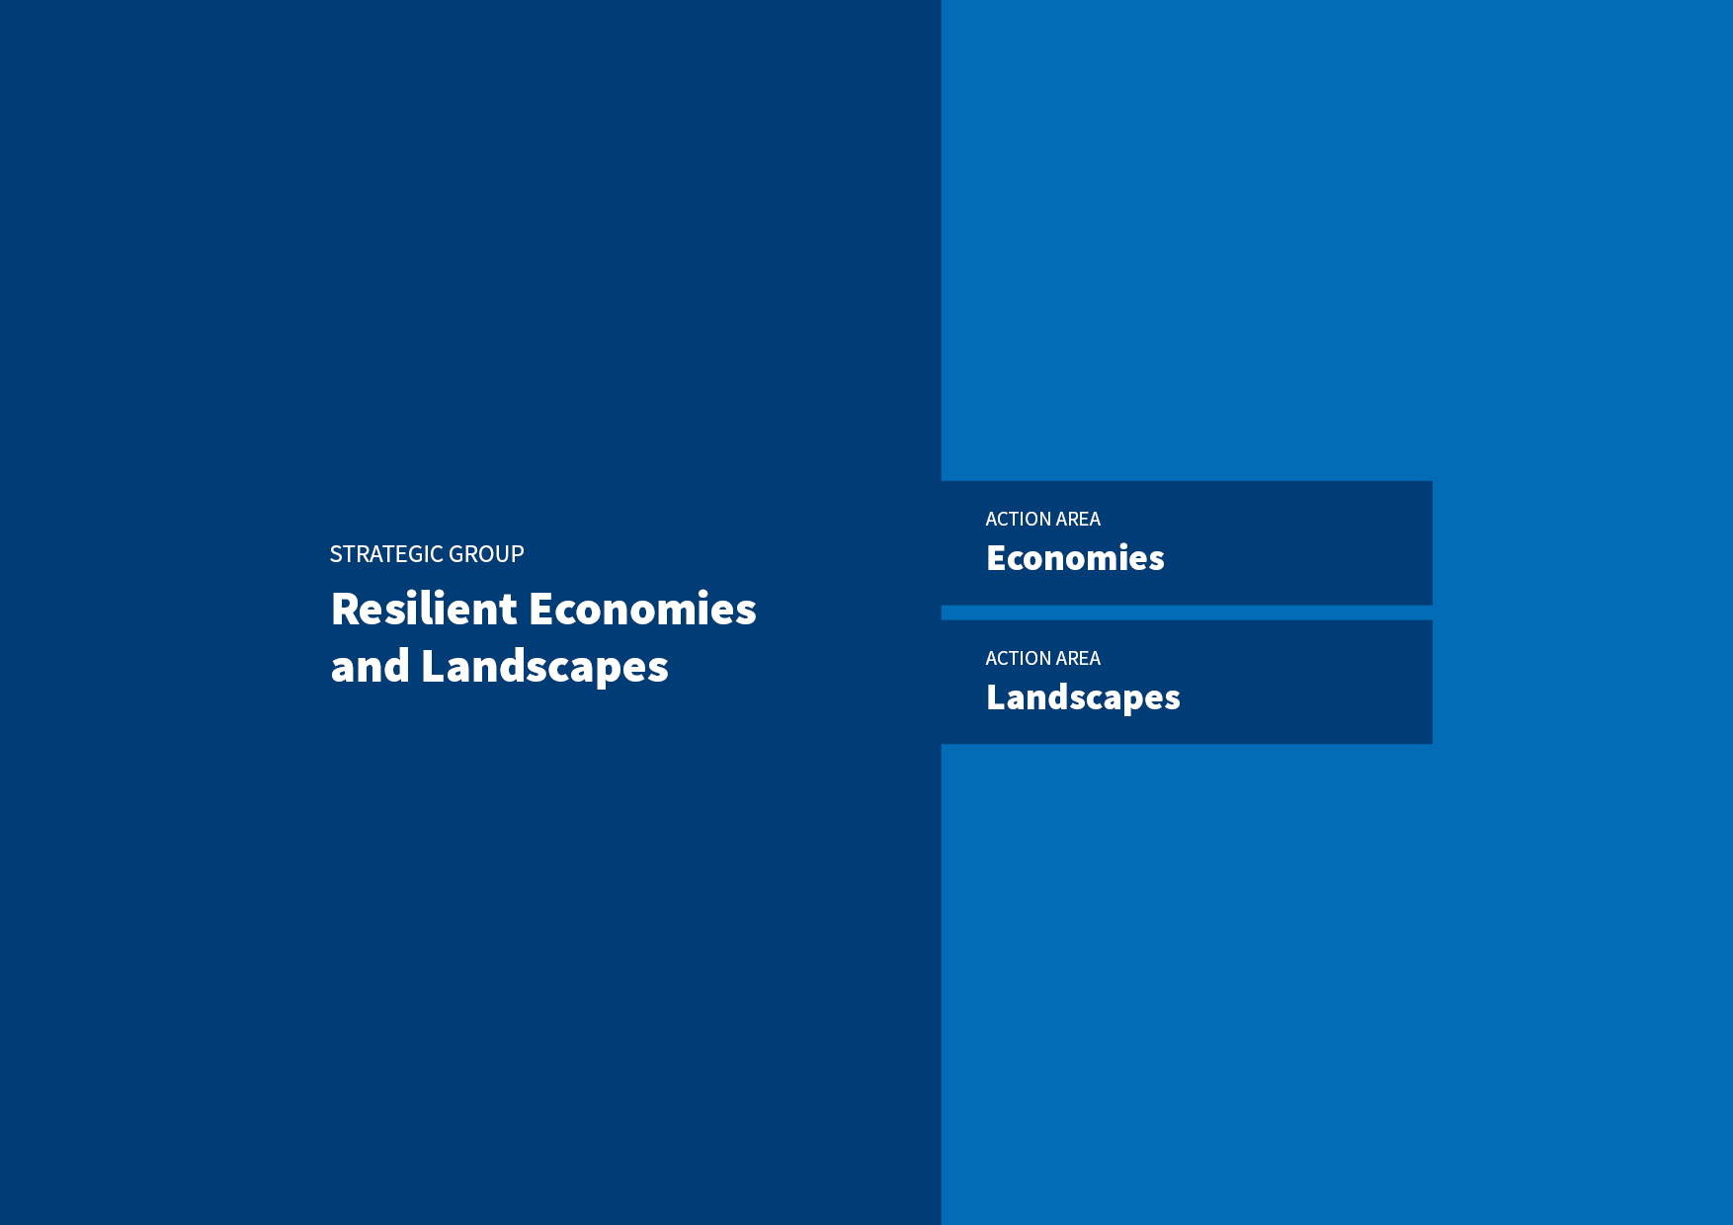

ACTION AREA
Economies

INTERVENTION 1
Foresight
MTAP Specific Outcomes | MTAP Outcome targets 2026 | Baseline Situation 2022 | Key milestones for Specific Outcome targets till 2026 | Key Outputs
Decision makers respond to evidence and adopt approaches that enable just transitions to green, resilient, gender responsive, and circular mountain economies under different climate change scenarios | At least 3 RMCs out of 5 focus countries respond and adapt gender responsive plans and programs to different future scenarios.  (India, Pakistan, Nepal, Bhutan, Bangladesh) | RMCs policies related to climate change adaptation and development plans do not have foresight on livelihood and economies options under different climate and socio-economic scenarios and time periods. This is an important knowledge gaps in the present plans that hinders anticipatory and GESI responsive and transformative adaptation. | 2023: Scoping of strategic foresight partners and building of a common understanding of needs through consultative process.  2023: A technical report on COVID-19 lessons for preparing for future non/climatic shocks.  2024: Co-generated gender responsive participatory local scale scenarios with partners and mountain communities including vulnerable groups and women in at least two sites/RMCs.  2024: A technical report on COVID-19 lessons for preparing for future non/climatic shocks published  2025: Regional synthesis of foresight action research made available  2026: Sub national/local governments in at least 2 RMCs integrate co-created GESI responsive participatory scenarios in their plans/programs. | Evidence for anticipatory adaptation developed through foresight assessment and scenario planning for climate and non-climatic changes in the HKH region.
 |  | Migration is one of the most widely used strategies used by households to adapt to various changes and meet their aspirations. However, RMC policies/plans relating to local development and climate change adaptation do not adequately consider migrant population and multi-local livelihoods. | 2023: Common understanding of migration as an adaptation strategy built with stakeholders through consultative process.  2024: Co-generated evidence, on conditions under which migration can be an effective adaptation strategy.  2025: Sub national governments in 2 RMCs piloted the co-created decision-support tools in their plans/programs.  2026: Evaluation tool for migration as effective adaptation developed at regional/global scale and communicated effectively to the regional decision makers. | Evaluation of migration-as-adaption conducted and decision support tools co-developed, piloted and integrated in local development and adaptation plans of at least 2 RMCs.

INTERVENTION 2
Livelihoods and Enterprises
MTAP Specific Outcomes | MTAP Outcome targets 2026 | Baseline Situation 2022 | Key milestones for Specific Outcome targets till 2026 | Key Outputs
Wider adoption of GESI responsive and innovative, green and climate resilient solutions at scale for HKH mountain products and services | At least in 3 RMCs GESI responsive solutions related to mountain products and services scaled up | Scaling of innovations and solutions on sustainable mountain livelihoods and green economies remains limited due to scattered piloting and unintegrated actions in the HKH.  Several successful pilots of resilient mountain solution options (such as for water management or pest management) have been implemented but not much scaling happening at speed across HKH.  There is high energy dependence on traditional and fossil fuel, the modern renewable energy share in the total final energy consumption in the HKH member countries is low ranging from 0.3%-11%.  Few government mechanisms in RMCs for promoting solutions/ innovations linked to NDC/NAP  There are a few government mechanisms (i.e., climate smart village procedure, 2073, Nepal, Bhutan flagship programme )  in RMCs for mobilizing investments and promoting innovations and solutions on sustainable livelihoods and green economies. | 2023: Viable sustainable mountain livelihood opportunities identified (e.g. natural/agroecological farming, other products and services) along with key barriers to uptake and scaling.  2023: Evidence documented and made available on the effectiveness of natural farming solutions in Nepal (GRAPE in Nepal).  2024: Evidence documented and made available on the effectiveness of sustainable, resilient and inclusive agriculture solutions  2024: Co-developed strategy methods, processes and partnerships for scaling of GESI responsive mountain livelihood solutions on (e.g. natural farming, renewable energy for farmers/households) and food security, and approaches and processes for scaling.  2025: Customized and tested (proof of concept) selected scalable solutions on livelihood.  2025: Capacity building for relevant stakeholders on various aspects of scaling of GESI responsive solutions organized in 3 RMCs  2025: Strengthen existing knowledge portal for knowledge exchange and cross learning on innovations, solutions, practices and processes for wider adoption.  2026: Use of evidence/generated knowledge for scaling up mountain products and services in at least 3 RMCs.. | Evidence and knowledge generated on GESI responsive solutions on sustainable livelihoods and its enabling environment (e.g., natural/ecological farming, other products, and services) along with key barriers to uptake and scaling in 3 RMCs (Nepal, Bhutan and Pakistan)
Robust and highly responsive institutional and policy environment for gender responsive, green, and circular mountain entrepreneurship | At least 4 RMCs mobilise investments and innovations through regional, national, and local level institutional mechanisms for high value mountain products and services | Scattered and fragmented information on enabling environment for green, GESI responsive, and circular enterprises and promotion for high-value mountain products and services.  The aspects of green, resilience, circularity and GESI responsive ness are still evolving and is at nascent stage in policies related to enterprises and economies in RMCs.  Nepal and Bhutan  ICIMOD has supported preliminary discussions on development of Start-up policy, .  India:  Overall start up environment is robust but mountain context with limited start-ups, investments, innovation, and policy.  GRIC coverage in policies for mountain is not clear.  Pakistan: A few private players with limited interventions on mountain specific policies on investments, innovations and start up ecosystem. No or less focus on GRIC. | 2023: Assessment report on enabling environment for green and GESI responsive enterprises for high value mountain products and services.  2024: Co-developed business solutions (based on technology, innovation, financial and digital) on selected value chains (high value mountain products).  2025: Established guidelines and operationalized challenge/seed fund focused on women and youth through incubation centres.  2025: Protocol document for green, GESI responsive and green enterprises developed and shared in 4 RMCs (Nepal, Bhutan, India and Pakistan)  2026: Fostered regional networks for exchange learning on policy environment, innovation, and investments for cross learning, improving capacities and leveraging investments. | Enabling environment for green and GESI responsive enterprises assessed, and business solutions co-developed, incubated and shared for improving capacities and leveraging investments
Wider adoption of gender responsive, innovative, green and climate resilient solutions at scale for HKH mountain products and services | At least 3 RMCs (Bhutan, Nepal and Pakistan) use ICIMOD inputs in policy and decision- making processes to enable transitions towards sustainable mountain tourism | Sustainable tourism at regional and global levels is emerging an opportunity to address gaps. At both regional and national levels there is inadequate analysis and understanding of the potential and pathways for sustainable tourism in the HKH.  Bhutan and Nepal offer opportunities to analyse comparative policy options, risks and opportunities (benefits, GESI etc.)  These gaps reinforce the kinds of challenges facing RMCs to make informed decisions (policy response, planning and budgeting) for transitions to sustainable mountain tourism. | 2023: Policy options, challenges and opportunities for sustainable mountain tourism and climate action identified.  2024: Evidence documented and made available on sustainable and climate resilient mountain tourism to initiate policy engagement in at least 3 RMCs (Bhutan, Nepal and Pakistan)  2025: Tailored knowledge products developed for policy inputs and institutional capacity building for sustainable and climate resilient mountain tourism  2025: Technical support provided to sub-national governments in at least 3 RMCs to integrate measures to promote sustainable mountain tourism in local and sub-national policies.  2026: Technical support provided to sub-national governments in at least 3 RMCs to integrate measures to promote sustainable mountain tourism in local and sub-national policies. | Sustainable mountain tourism promoted through knowledge generation and exchange at regional and global forums.

INTERVENTION 3
Settlements
MTAP Specific Outcomes | MTAP Outcome targets 2026 | Baseline Situation 2022 | Key milestones for Specific Outcome targets till 2026 | Key Output
Decision makers respond to evidence and adopt approaches that enable just transitions to green, resilient, gender responsive and circular mountain economies to sustain mountain communities under different climate change scenarios. | At least 3 RMCs (Bhutan, Nepal and Pakistan) use ICIMOD’s inputs in local planning processes for promoting sustainable mountain settlement initiatives. | Despite some work on human settlements in other regions (see Annex table 1A), there I data and knowledge gap on the issues, risks and opportunity on mountain settlements in HKH.  Country specific policies and strategies given here. | 2023: Key priorities, policies, strategies, and key stakeholders, identified in the field of sustainable mountain settlements and a scoping assessment is co-designed and initiated.  2024: Scoping assessment report on how to build more sustainable mountain settlements (2024)  2025: Documented and piloted scalable solutions on sustainable and climate resilient buildings in the mountain context.  2025: Strengthened capacity of stakeholders on alternative building materials and enabling environments.  2025: Demonstrated proof of concept prototype solutions for waste management in 3 RMCs.  2026: Documented and piloted scalable solutions on sustainable and climate resilient buildings in the mountain context.  2026: Co-developed sub-national framework and guidelines on sustainable and climate resilient buildings in the mountains. | Evidence generated on sustainable mountain settlement issues, risks and opportunities for designing future intervention and resource mobilization.
INTERVENTION 4
Renewable Energy
MTAP Specific Outcomes | MTAP Outcome targets 2026 | Baseline Situation 2022 | Key milestones for Specific Outcome targets till 2026 | Key Output
Decision makers respond to evidence and adopt approaches that enable just transitions to green, resilient, gender responsive, and circular mountain economies under different climate change scenarios. | At least 2 RMCs energy nodal agencies (Bhutan and Nepal) use ICIMOD inputs in supporting plans and implementation processes for productive use of renewable energy | Renewable energy nodal agencies of Nepal and Bhutan lacks decision support tools for identifying RE demand for irrigation in agriculture  Renewable energy nodal agencies of Nepal and Bhutan has limited sector specific knowledge in effective integration of productive use of RE e.g. agriculture sector  Renewable energy nodal agency of Bhutan has limited institutional capabilities and mechanisms to implement RE solutions for productive use | 2024 An innovative digital decision support platform developed and made available to identify opportunities for potential renewable energy demand in irrigation in Nepal  2024 Proof of concept for selected solutions on renewable energy in Agriculture in Nepal  2025 An innovative digital decision support platform developed and made available to identify opportunities for potential renewable energy demand in irrigation in Bhutan.  2025 Generated knowledge and evidence from the tested solutions for promoting productive use of renewable energy.  2025 Capacity of relevant institutions in 2 RMCs enhanced to leverage the innovative platform for decision-support on RE lift irrigation systems.  2026: Use of evidence and generated knowledge for engagement in plans and implementation processes for productive use of Renewable energy. | Develop PURE platform for Nepal and Bhutan  Proof of solutions and develop knowledge products to bridge the sector gaps for effective integration of productive use of RE in agriculture  Conduct capacity building to strengthen institutional capabilities and mechanisms to implement RE solutions for productive use

ACTION AREA
Landscapes

INTERVENTION 1
Springs
MTAP Specific Outcomes | MTAP Outcome targets 2026 | Baseline Situation 2022 | Key milestones for Specific Outcome targets till 2026 | Key Outputs
Springshed management policies adopted at national and sub-national levels | At least 3 RMCs include Springshed management in their national policies and strategies (water, environment and NRM)  At least 4 RMCs include springshed management in their sub-national level policies and strategies.  in their sub-national level | Spring revival is part of Bhutan’s Water Flagship Programme. In India, NITI Aayog’s policy directions for spring revival watershed guidelines with springs are being put into action. In Nepal, the National Water policy include spring rejuvenation but lacks implementation. In Bangladesh’s MOCHTA has initiated springshed projects in CHT but there is no policy. In Pakistan there is no policy response, but cases studies show scope for spring revival. Water policy includes groundwater management.  Sub-national policies and strategies (provincial and local level) are not existing/adequate for spring revival in all RMCs. | 2023: Co-production of policy analysis for Springshed management for 5 RMCs: BD, BT, IN, NP, PK.  2024: RMCs initiate springshed strategy formulation process at national level in India, Bangladesh, Nepal, Pakistan.  2025 GESI responsive springshed management piloted in Bhutan, India, Bangladesh, Nepal and Pakistan  2025: Government of Bangladesh starts integrating springshed management as and nature-based solution for water security in their plans and budgets.  2025: GESI responsive springshed protocols included in development plans of four IHR states and CHT Board (India and Bangladesh).  2026: Springsheds better managed in at least three RMCs. | Regional stocktake made available on springshed management in RMCs, with focus on policy and enabling environment.  Regional spring outlook co-published.  Policies supported through effective outreach, advocacy, and engagement processes.  Findings from research on springs contribution to base flows and biodiversity published.  New funding leveraged for spring revival for western HKH.
Strengthened capability of RMC institutions across HKH to deliver and implement sustainable and GESI responsive management of springsheds | At least one mandated institution/training centre (in three RMCs) includes GESI responsive springshed management in their programmes.  Three RMCs put modified spring revival protocols into practice. | No state institutions are offering sustained training courses for practitioners or managers on spring revival in the RMCs. | 2023: Six-step GESI responsive springshed management protocol customized with partners.  2024: Identify and engage with key public institutions for scaling (Bhutan, India, Nepal, Bangladesh, Pakistan).  2025: Training courses and capacity building curricula co-developed with partners, based on customized six-step spring revival protocol.  2026: Key mandated public institutions running training courses on their own.  2026: At least 3 RMCs set aside resources for springshed management at sub-national level  2026: Significantly increased number of springsheds managed under GESI responsive protocol. | Community based pilots established, and existing ones strengthened together with local governments across all five RMCs.  Cost-benefit and impact analysis of spring revival initiatives conducted in the Eastern HKH  Strategic partnerships developed with mandated institutions for scaling and capacity building.

INTERVENTION 2
Rangelands and Wetlands
MTAP Specific Outcomes | MTAP Outcome targets 2026 | Baseline Situation 2022 | Key milestones for Specific Outcome targets till 2026 | Key Outputs
RMCs adopt integrated and multisectoral evidence-based policies that support conservation, restoration, and sustainable management of rangelands (and their wetlands) | In at least 3 countries(Bhutan, Nepal and G.B Pakistan), government departments are using updated and well-integrated data and information on rangelands, herders and pastoral uses of grazing areas to guide rangeland management policies and decision making | At present, only China has made attempts to integrate rangeland information into decision systems, but these are only accessible by government departments. In the rest of the RMCs, there is no monitoring and systematic collection and management of data related to rangeland resources and their uses. Information and data on rangelands and use are either non-existent or scattered in different places hardly accessible to users for more effective decision making on rangeland management. There is a demand and opportunity for generating data and integrating it into a single interactive platform for easy access and quick feedback taking advantages in advances in geospatial, ICT and digital technologies. | 2023: Partnership and methods established and jointly agreed for regional rangelands assessment  2024: Field research on social-ecological changes, vulnerabilities, and transformation in rangelands of HKH initiated in Bhutan, India, Nepal and Pakistan  2024: Communication materials on regional-level knowledge & information on rangelands/wetlands, pastoralism and trends of change ready for wider dissemination  2024: Initial design of Interactive Information Management Platform (IIMP) developed with partners  2025: Information (data and maps) on grazing areas, herders and seasonal use of grazing areas for Nepal, Bhutan and . Pakistan compiled and shared with policy makers  2025: Best Practices on Managing Rangelands for Multiple Benefits, Sustainable Rangelands Management as NbS to Societal Challenges and Cases of Pastoral Resilience in HKH published and disseminated.  2026: A Regional Assessment of Rangelands and Pastoralism in HKH published jointly with partners integrating all the updated information and knowledge generated through project implementation.  2026: Synthesized knowledge, information and data sets integrated into government databases for policy development and rangelands management decisions | An understanding of rangeland resources, ecosystems, and their contributions to people of HKH developed.  A user driven information management platform co-developed, that will support participatory rangeland management and evidence-based decision making (GB. Pakistan, Bhutan and Nepal
 | At least 3 RMCs (Bhutan, Nepal and Pakistan) developed and implemented rangeland policies and plans that ensure integrated management of rangelands for multiple ecosystem services | Not all HKH countries have specific policies on rangelands. In most, rangelands are subject to sectoral and uncoordinated policies that do not reflect the need for multi-sectoral collaboration and GESI responsive stakeholder participation. In many countries, related policies are general, gender insensitive and unsupported by robust evidence on status, trends, and possible new management approaches. There is however a fair demand coming from RMCs for improving rangeland management policies. The Provincial Government of Gilgit Baltistan, Pakistan requested ICIMOD for policy support for their rangeland policy; the Royal Government of Bhutan, under its Land Act, is in the process of redistributing rangelands to real users; and in Nepal, the new Land Use Regulations (2022) require governments at different levels to develop land use plans. The Bhutan government started a process of redistributing pasture to herders if they develop a management plan, opportunities for entry have been identified and discussed with government). In Nepal. But in Nepal, inadequate coordination among the many government departments that have rangelands mandates has affected the management effectiveness and led to policy disharmony. Lack of data or the difficulties in data accessibility also affected the quality and timeliness of decisions. | 2023: Policy roadmap agreed with major stakeholders in Pakistan, Bhutan, and Nepal  2024: Rangeland policy approved by the Gilgit Baltistan Provincial Government (Pakistan) for implementation.  2024: Technologies, innovative approaches and institutions designed and piloted in Bhutan, Nepal and Pakistan  2025 : Participatory rangeland/pasture management planning at community/household level demonstrated in Nepal and Bhutan  2025: Technologies for Rangeland Restoration and Winter Fodder Development piloted in Bhutan, Nepal and Pakistan.  2025: Technical Guidelines for Prescribed Burning adopted by government of Bhutan as standard practice for rangeland management.  2025: Management Plan reflecting NbS and GESI for Gangtey -Phobji Ramsar Site developed and approved by the Government of Bhutan for implementation; (almost completed in 2024)  2025: Rangeland Management Strategy and Action Plan integrating NbS and GESI perspectives for Karnali Province of Nepal approved by the government for implementation,  (almost completed in 2024)  2026: Rangeland policies and programmes implemented in Bhutan, Nepal and Pakistan including upscaling of tested technologies, approaches and mechanisms. | Participatory, integrated and GESI responsive planning and policy-making processes demonstrated for managing rangelands for multiple ecosystem services facilitated (PK, Bh, and Np)  Innovative technologies, best practices and approaches demonstrated for rangeland management (Bhutan, NP, and PK)
User-led institutions are strengthened to promote sustainable management of rangelands and pastoralist livelihoods at regional, national, and subnational level | At least 4 yak herders associations and/or rangeland societies influencing policy and investments related to rangelands | There are no regional civil society rangeland-related networks, especially those including pastoralists. In China, there is a rangeland research society, but that is mainly for scientists. With the support of ICIMOD, herder associations have already been established in Bhutan, and initiated in India and Nepal. | 2023: Registration of yak herder federation in Nepal  2023: Capacity building and regional learning and technology transfer plan co-developed with partners  2024: Registration of Yak herder association in India (Sikkim and UTL) and Pakistan  2024: At least 100 RMC partners/stakeholders trained or exposed to events sharing best practices for managing rangelands for multiple benefits  2024: Regional community of practice formed to support agenda of rangelands and pastoralism  2025: Registration of Yak herder association in Pakistan  2025: Charter and structure for a regional network of community of practice co-developed with and agreed by at least 3 RMCs  2026: A regional network of community of practice on rangelands and pastoralism launched at IYRP 2026, joined by at least three RMCs.  2026: Staff in partner institutions are using newly acquired knowledge and skills to manage rangeland resources | Technical assistance services provided to establishment of national and regional yak herder federations and Regional Rangeland Society  Institutional capacities developed for partners and stakeholders in rangeland management (especially in BH, NP and PK)

INTERVENTION 3
Incentives
MTAP Specific Outcomes | MTAP Outcome targets 2026 | Baseline Situation 2022 | Key milestones for Specific Outcome targets till 2026 | *Key outputs
GESI responsive incentive mechanisms adopted that incentivize and reward individuals and communities for protecting and restoring biodiversity (and delivering climate sequestration benefits) | At least in three RMCs key policy makers, impact investors and civil society organizations use key elements of NbS and NCA work | There is limited understanding of the value of ecosystems and their services to mountain and downstream communities, and application of incentive measures across the HKH, including especially measures that will reward local custodians of biodiversity and implementors of NbS is very limited. This is despite quite some new thinking and application in these areas internationally.  Governments of RMCs have shown keen interest, but there is a gap in policy and practice with support for payment for environmental services schemes being sporadic. | 2023: Review and better understanding of wider array of incentive measures and their applicability to the HKH  2024: valuation and accounting system for HKH ecosystem services  2024: MEL platform established for NbS to support investment and scaling  2024: Potential investment and incentive mechanism cases developed to promote and scale NbS  2025: Co-design and operationalize incentive measures for NbS and ecosystem restoration in two RMCs.  2025: Policy makers from three RMCs brought onboard for NbS related incentives through effective engagement process.  2026: In three countries, relevant stakeholders use inputs from ICIMOD to design incentive mechanism for scaling NbS  2026: At least two governments (local or national) commit to integrating incentives into ecosystem and landscape restoration | Review of incentive measures carried out in the HKH and other regions.  Valuations of ecosystem services conducted in select countries of HKH.  Pilots and case study reports made available of appropriate incentives measures for NbS for water, DRR and mountain livelihoods (jointly done with AAA and AAC). Potentially in Ba, Bh, Ne, In.
More gender responsive and effective management and conservation of mountain biodiversity though other effective area-based conservation measures (OECMs) | At least three RMCs adopt OECM guidelines for mountain biodiversity that acknowledge and incorporate socio-economic links and dependencies on biodiversity by marginalized and vulnerable communities | RMCs have committed for OECM but none of the HKH RMCs has guideline and baseline on OECM, except India.  IPLCs and private sectors have shown keen interest, but gap in policy and practice. | 2023: Scoping of OECM potential and governance mechanisms  2024: Mapping of potential OECMs across the HKH, and selection of priority hotspots for piloting.  2024: Regional Cooperation on Transboundary OECM initiated.  2025: Key policy and decision makers involved in capacity building and awareness raising to incorporate key OECMs in relevant biodiversity management policies  2025: Prospects explored for transboundary OECM in one landscape shared by two or more countries  2025: At least two RMC institutions supported for preparing OECM guidelines | Scoping review of lessons and potential of OECMs in HKH mountain landscapes outside protected areas, and mapping of priority hotspots made available for GESI responsive landscape governance.  Ba, Bh, In, Np, Pk  Regional stakeholder engaged for OECM Guidelines  Science-policy dialogue organized for policy uptake.  Capacities built for IPLCs
2026: At least two RMCs institutions supported for preparing OECM guidelines

2026: Collaboration with international organizations and donor agencies to garner support for transboundary OECMs.

2026: Assisting RMCs and IPLCs for reporting OECM to global database. i.e., World Database on OECM.
GESI responsive incentive mechanisms adopted that incentivize and reward individuals and communities for protecting and restoring biodiversity (and delivering climate sequestration benefits | Increased use of regional knowledge forums and networks for strengthening regional collaboration (e.g. science-policy dialogues) through high quality evidence generated from the research. | There is limited understanding of the value of ecosystems and their services to mountain and downstream communities, and application of incentive measures across the HKH, including especially measures that will reward local custodians of biodiversity and implementors of NbS is very limited. This is despite quite some new thinking and application in these areas internationally.  Governments of RMCs have shown keen interest, but there is a gap in policy and practice with support for payment for environmental services schemes being sporadic. | 2023: Develop a FLR workplan on capacity building with partners in India  2023: Research design, finalization of methodology, information, and data collection (both survey and satellite based) for analysis.  2023: Update on land cover and forest monitoring data including estimation of above ground forest carbon  2024: Geospatial approaches identified to strengthen the basis for incentive design and planning  2024: Establishment of economic basis for forest landscape restoration  2024: Capacity built to actioning incentives for forest landscape restoration.  2025: RECAP4NDC: Impact pathways, evidence base, and capacity strengthened for Forest Landscape Restoration (FLR)  2025: SERVIR: Geospatial data on land cover and forest monitoring including hotspot mapping generated to inform ecosystem management and provide the basis for incentives  2025: SANDEE: Synthesis of the regional research (manuscripts and policy brief drafted, published, widely disseminated)  2026: RECAP4NDC: Plan of implementation for FLR and wider dissemination of knowledge and outputs globally to scale FLR  2026: Strengthen evidence base on spatial flow of ecosystem services to incentivize landscape restoration (SERVIR+)  2026: SANDEE: Final dissemination and exploration of biodiversity/carbon-based incentives for FLR | Research output synthesized from all four countries and disseminated.  Service area on land cover, land use and ecosystems facilitated.  At least 3 models successfully piloted where local communities, women and marginalized groups demonstrate ecological, socio-economic, governance, and climate change related benefits from FLR.

INTERVENTION 4

Human-wildlife coexistence

MTAP Specific Outcomes | MTAP Outcome targets 2026 | Baseline Situation 2022 | Key milestones for Specific Outcome targets till 2026 | Key Outputs
Human-wildlife coexistence (HWC) facilitated through a systems approach to addressing human-wildlife conflict. | Coexistence mechanisms to address human-wildlife conflict are adopted by three countries and made available for two transboundary landscapes.  (i.e. Kanchenjunga Landscape (KL): Bh, In, Np; Hindu Kush Karakoram Pamir Landscape (HKPL): Ch, Pk] | Despite increasing incidence of human wildlife conflict across the region and multiple losses to crops, livestock and human life, there are few effective policy and practice solutions. The situation is becoming increasing acute and there are increasing concerns about transboundary conflicts as wildlife moves across borders. Despite that no regional coordination or information mechanism to monitor or manage transboundary HWC exists. A regional HWC Task Force for KL was initiated in 2022. | 2023: Co-generation of a synthesis of evidence on GESI-sensitive human wildlife coexistence solutions relevant to HKH  2023: Regional program proposal submitted for Kanchenjunga Landscape (KL)  2024: Coexistence solutions reviewed, compiled, and analysed  2024: Pilot coexistence solutions initiated in the Kangchenjunga Landscape (India and Nepal)  2025: Co-designed solutions explored and widely discussed to define its effectiveness  2025: Co-designed solutions are tested in situ  2026: Tested solutions are evaluated for effectiveness and potential for scaling  2026: Regional HWC Task Force for Kanchenjunga Landscape (KL) institutionalised | Review of evidence on coexistence solutions from national, regional, and global levels made available.  Bh, Ch, In, Np, Pk
 |  |  |  | Coexistence solutions tested in at least one transboundary landscape (KL)
 |  |  |  | Technical assistance services provided underpinning institutionalization of a Regional HWC Task Force in one transboundary landscape (KL) (Bh, In, Np)

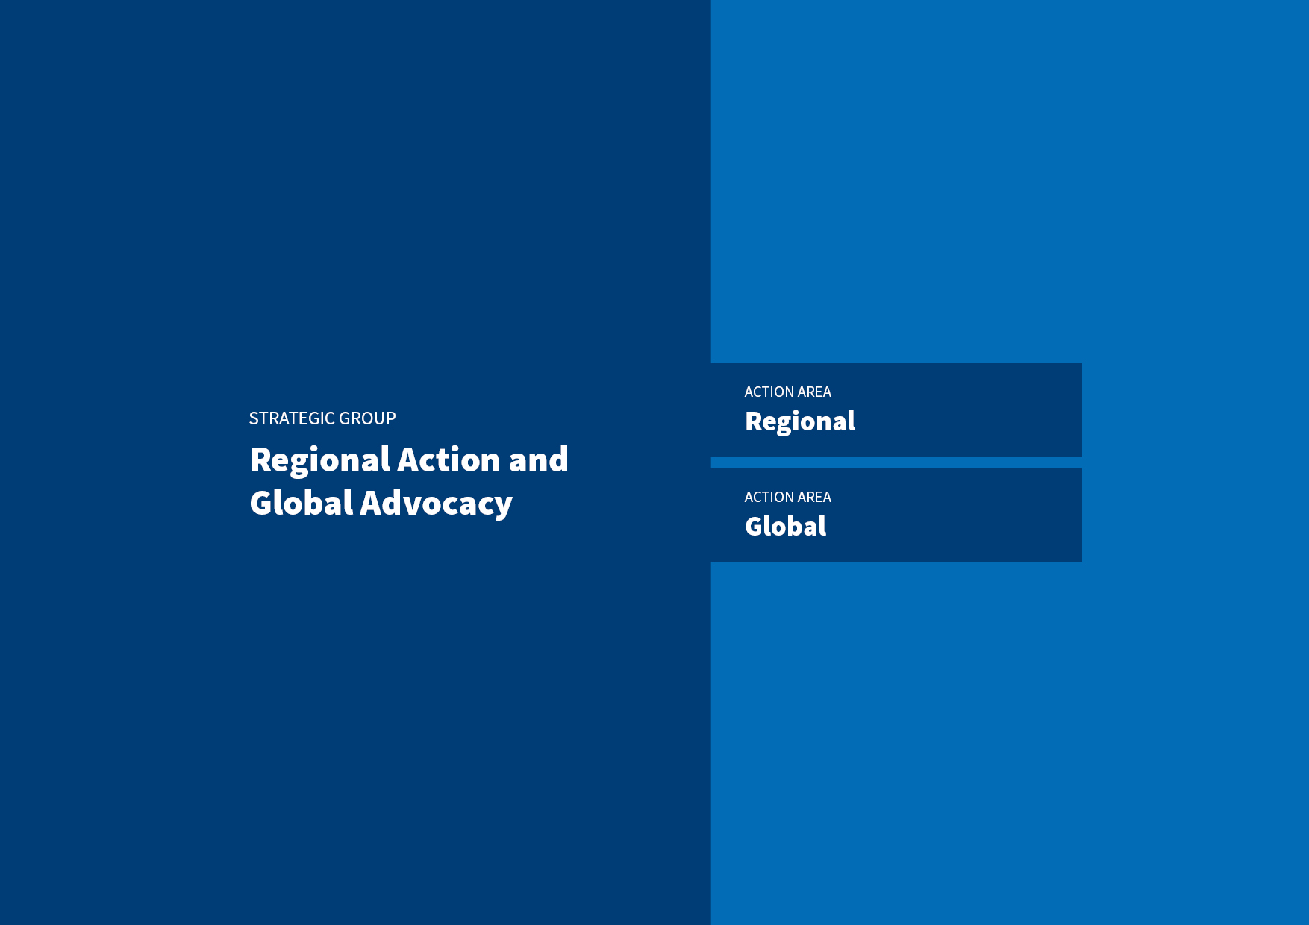

ACTION AREA
Regional

INTERVENTION 1
Regional Cooperation
MTAP Specific Outcomes | MTAP Outcome targets 2026 | Baseline Situation 2022 | Key milestones for Specific Outcome targets till 2026 | *Key outputs
High-level regional mechanism effectively operating for regional cooperation and collaboration around green, GESI responsive and resilient development in the HKH. | The high-level regional mechanism is formalised and issues at least two regional declarations and/or protocols on key topics. | Several HKH risks and benefits are transboundary, yet no functional mechanism exists in the HKH to foster regional cooperation. However, ministers of the eight HKH countries have signed a Ministerial Declaration in 2020 agreeing to constitute a task force, which has met six times since its inception, to assess the feasibility of establishing a high-level regional mechanism. | 2023: Final HLTF recommendation report made available for ministerial summit  2024: The 2nd Ministerial Declaration signed.  2024: The Charter of the HKH Council drafted  2024: Thematic Working Group/s formalised  2025: Foster engagements and partnerships with relevant regional and sub-regional mechanisms for enhanced regional cooperation and collaboration.  2025: Thematic Working Groups on Cryosphere and Air Quality Management formalized.  2026: The high-level regional mechanism is operationalised.  2026: Thematic Working Groups on Cryosphere and Air Quality Management formalized. | Technical/admin assistance services provided underpinning the following:  HLTF meeting organised.  2nd Ministerial Mountain  Summit organised.  Setting-up Thematic Working Groups established  3rd Ministerial Mountain Summit organised
Increased use of regional knowledge forums and networks for strengthening regional cooperation and collaboration (e.g., Science Policy, dialogues) through high quality evidence and skill | At least 5 RMCs used HKH thematic assessments to determine policy, planning, and programme priorities. | Whilst there is a fair amount of evidence available nationally (HIMAP) up to now it has not been taken into any HKH regional forum and debated actively with policy makers in a systematic way.  Evidence based policy making is a significant challenge most of the HKH countries face. As many environmental and climate change issues are transboundary, there is a lack of regional knowledge and policy platforms to address such issues. | 2023: Recommendations issued for collective action on 2nd HKH Science-Policy Forum  2024: Thematic Assessment on priority regional topics initiated  2024: Recommendations issued by National level Science-policy dialogues to tackle national and regional challenges/ issues.  2024: National laws, policies and plans on environment and climate change are supported by the HKH parliamentarians.  2025: At least three Thematic Assessments on priority regional topics initiated (HKH Springs on-going)  2025: Recommendations issued by the 3rd HKH Science-Policy Forum  2025: Parliamentarians enabled to support national laws/policies on environment and climate change in at least 3 RMCs.  2026: At least three Thematic Assessments on priority regional topics initiated  2026: Recommendations issued by the 3rd HKH Science-Policy Forum  2026: Parliamentarians use ICIMOD inputs in the preparation of national laws/policies on environment and climate change in at least 3 RMCs. | National science-policy dialogues organized (all RMCs)  HKH Science-Policy Forums organized (all RMCs)  Thematic Working Group groups established and supported with thematic assessments on high priority regional issues

INTERVENTION 2
Regional Information Service
MTAP Specific Outcomes | MTAP 5 Outcome targets 2026 | Baseline Situation 2022 | Key milestones for Specific Outcome targets till 2026 | Key Outputs
Regional and national policy, planning and investment decisions influenced through improved access to data, information and insight on regional climate and environmental trends. | At least 5 key national institutions use Regional Information Service (RIS) that brings together multiple data sources and uses best of latest digital technology and enables tracking of key HKH-wide environmental indicators | Whilst data gaps in the HKH remain (e.g. on cryosphere and permafrost), in many other areas much data and information has been collected over the last decades. But it is often sitting within different institutions in different countries and therefore challenging to access to support decision making.  The first HKH Assessment report coordinated by ICIMOD aimed to address this but much more needs to be done across the region to deliver coordinated and accessible regional information services. | 2023: Operational model setup for regional short term and long-term forecasts/outlooks on drought, high impact weather events  2023: Methodologies developed for SDG 15 indicators, sub-national forest mapping  2024. Responsible Ministries / Departments in at least 4 RMCs use ICIMOD data and evidence in their decision making.  2024: A collaborative Regional Information Service established for the HKH  2024-2025. Key outlooks on drought, forest and floods made available for regional stakeholders.  2025: Regional Database System (RDS) strengthened to improve information access and use  2025: GIT tools and methodologies used by at least four RMC partners.  2025: At least two new information services developed and disseminated.  2026: Increased user engagement for using data and information services from RDS.  2026: GIT tools and methodologies used by three additional RMC partners (to be identified)  2026: At least three RMCs adopt the newly developed information services. | Periodic insights, forecasts, seasonal outlooks on high impact weather, floods, forest fires and droughts produced and shared with relevant agencies each year.  Availability and increased access to GIT and EO applications which are co-developed with stakeholders to tailor to their needs.  Improved coordination and collaboration, across disciplines, internationally, regionally and within ICIMOD (for SDG15).  Regional Database System upgraded and made part of regional information service

INTERVENTION 3
Regional Networks
MTAP Specific Outcomes | MTAP Outcome targets 2026 | Baseline Situation 2022 | Key milestones for Specific Outcome targets till 2026 | Key Outputs
Increased use of regional knowledge forums and networks for strengthening regional cooperation and collaboration (e.g., Science Policy, dialogues) through high-quality evidence and skill. | All RMCs are active in regional knowledge forums and networks, leading to new regional collaborations. | SANDEE with scholars is a rich knowledge network specialized in environmental and resource economics. The network members have been producing high quality research and evidence base through rigorous research for informing development policies in the region. However, there is a disconnect between evidence generation by SANDEE and its use in policy and practice. Likewise, SANDEE scholars can offer new knowledge and insights to national and regional SPFs and support national and regional policy processes in the HKH. | 2023 & 2024: SANDEE scholars join relevant Thematic Working Groups of the HKH Council and bring new knowledge and insights to the forums  2025: At least 100 researchers trained in Environmental and Resource Economics leading to strengthening the pool of well-trained human capital (who can take leadership positions in institution of higher education, provide policy advice and participate and contribute to SPF/Ds and TWGs)  2025: At least 8 research projects supported by ICIMOD completed by SANDEE researchers leading to new knowledge /evidence that inform SPF/D(s) and TWG(s)  2025: At least 30 research articles published by SANDEE alumni/scholars would be used as input at SPF/D(s) and Thematic Working Group(s) to inform policy and decision-making processes.  2026: At least 30 research articles published by SANDEE alumni/scholars that would be used as inputs for the SPF(s) and Thematic Working Group(s)  2026: At least 8 research projects supported by ICIMOD completed by SANDEE researchers leading to a new knowledge /evidence base that help informing SPF(s) and TWG(s)  2026: At least 100 researchers trained in Environmental and Resource Economics leading to strengthening the pool of well-trained human capital (who can take leadership position in institution of higher education, police advice and participating in SPFs and TWGs) | Researchers and faculty members have knowledge and skills on environmental economics and share their collaborative research outputs.
 | All RMCs are active in regional knowledge forums and networks leading to new regional collaborations. | Higher education institutions (HEIs) in the HKH make little efforts to collaborate with one another in the same country and neighbouring countries to conduct HKH focused policy oriented, problem-based solution-driven research on climate change and transboundary issues; the available knowledge and evidence is rarely used in policy making for mountain areas; 8 HUC Thematic Working Groups and Cross-Cutting Working Groups are active with Co-Leads and operate on a resource-sharing basis.  The majority of HUC full members in RMCs do not have institutional Gender and Diversity Policy (for both enrolment and recruitment) in place. | 2023: HUC TWGs bring new knowledge on directly relevant topics to national and regional science-policy forums.  2024: High-quality collaborative research outputs made available and shared in HKH Science-Policy Forums.  2024: (brought forward from 2025)  The HUC Academy resumed contributing to improved institutional capabilities in transdisciplinary research on Mountain issues.  2024: At least half of institutional members in the RMCs, where conducive environment exists, adopt Gender and Diversity Policy following HUC support  2025: HUC’s transition to autonomy is explored and its future status established either as an independent institution or as a network within ICIMOD (Recommendation of PAC Sub-Committee). | Effective HUC Secretariat that promotes collaborative research and mountain curriculum in alignment with SG1 and SG2 priorities.  TWGs collaborative research supported for high quality outputs by Secretariat.  HUC members supported in developing GESI and diversity policy

ACTION AREA
Global
INTERVENTION 1
Global Engagement
MTAP Specific Outcomes | MTAP Outcome targets 2026 | Baseline Situation 2022 | Key milestones for Specific Outcome targets till 2026 | Key Outputs
IPCC/IPBES periodic and thematic reports integrate HKH evidence and reflect unique challenges of mountain region. | IPCC: HKH knowledge enhanced in IPCC assessments by influencing the structure and inclusion of key RMC and ICIMOD authors.  IPBES using nexus and transformative change reports and influenced to include mountain section in the second global assessments report. | IPCC and IPBES reports recognise HKH as among the worst affected and most sensitive regions but have also highlighted the data deficiencies in this region e.g., IPBES 2019, AR6.  At the current stage - submission and contributions have been made & on-going in different global frameworks - Global Biodiversity Framework (GBF, 2022-2030); IPBES (2022-2024)  IPCC (Mountain Chapter, 2022, AR6 WGII); National: Periodic submissions by RMCs to global platforms. Mountains usually missing or not highlighted in submissions.  ICIMOD has observer status at CBD-IPBES and UNFCCC - IPCC | 2023: IPCC/IPBES: strategy and mechanism developed for contribution & engagements with focal points & authors.  2024: Position and involvement in IPCC AR7 design process secured  2024: IPBES: Nexus and transformative change assessment reports, approved by IPBES general assembly, reflect mountain concerns  2024: At least 2 HKH experts nominated as contributors to IPCC AR 7 report  2025: ICIMOD actively working with at least 3 RMC focal points for nomination of authors and topics for IPCC AR7 assessment cycle.  2025: Increased participation of experts from HKH RMCs in main 2nd Global Assessment Report. Learnings from transboundary landscapes reflected in forth-coming assessments  2026: Authors from RMCs have been nominated and ICIMOD actively working with and supporting them for the assessment process and reports  2026: Increased participation of experts from HKH RMCs in main 2nd Global Assessment Report. Learnings from transboundary landscapes reflected in forthcoming assessments. | IPBES: Contributions made to 1st order draft of nexus and transformative change assessment reports, 2nd global assessment (2026 -2028) and strategy for engagement developed.  IPCC: Strategy for engagement developed, and AR7 incorporates chapters relevant to HKH. Engagement agreed in AR 7 process of IPCC report 2028.  Strategy developed for engagement and contributions to in other MEA science/technical (IPBES, IPCC, etc.)  Contributions made to scientific committee of Mountain partnership – advocating mountain agenda/chapter
RMCs have a stronger capability to actively promote mountain issues in key forums of the global MEAs. | RMCs integrate evidence from HKH mountains in their country position papers within key forums of the global MEAs (SBSTTAs, SBIs, WGs, COPs2)  At least 2 constituted and subsidiary institutions use HKH related evidence in their engagements. | Currently, mountain concerns, targets, and indicators in most RMCs submissions to CBD and UNFCCC country submissions are limited. In addition, submissions, and contributions to both these MEAs from ICIMOD is ad hoc.  The HKH Ministerial declaration agreed to promote united voice for the HKH at global MEAs  Observer status at CBD and UNFCCC  National: Periodic submissions by RMCs to global platforms. Mountains usually missing or not highlighted in submissions (we have only engaged in few)  Reviving existing networks. PoW on Mountain Biodiversity is inactive and could be revived. | 2023: Submission to SB 58 and 59 and campaign for CoP28 supported  2023 onwards: (UNFCCC/CBD) Processes & mechanism in operation for integration of common mountain agenda into global processes  2024: CBD COP 16 and UNFCCC COP 29 (including SBSTTA and UNFCCC SBSTA) strategies for engagement on HKH/mountain issues delivered and mountains mentioned in position papers and submissions made by RMCs and ICIMOD  2023-2024: Mountain specific indicators/targets incorporated in NBSAP of at least 2 RMCs (GESI responsive where relevant)  2025: Processes and mechanism in operation for integration of mountain agenda into global processes (UNFCCC)  2025: Joint submissions on mountain issues at least 2 RMCs in global processes.  2025: Processes and mechanism in operation for integration of the mountain agenda into global processes (CBD)  2026: Mountains are part of annual dialogue in UNFCCC.  2026: Revival of Programme of Work on Mountain Biodiversity initiated and supported.  2026: HKH’s key priority areas identified and key messages on these areas from HKH in global forums (UNCBD and UNFCCC) | RMC engagement strategy developed for UNFCCC, UNCBD, Sendai etc.  Regional consultation workshop organised on climate change Policy and Investment in the Hindu Kush-Himalaya  CBD and UNFCCC focal point meetings and workshop organized for all RMCs.  Capacity building workshops organised focusing on negotiation skills for MEAs.
Effective international action on sustainable mountain development advocated through regional and global mountain alliances​. | Youth & GESI networks, partners and key regional mountain organizations across the globe mobilized in promoting mountains in global MEAs | Existing global partnerships are working on their own and while they are moderately active, the scale of the problems facing mountain regions and their wider global implications warrants a much higher degree of collective engagement.  Limited level of engagements/outreach of mountain youth and GESI networks  regionally and internationally | 2023: Strategy on global partnerships including collaborations with global strategic platforms like the steering committees (Mountain Partnership), high level forums  2024: A Strategy and a mechanism designed and initiated for engagements and outreach for global engagements to amplify HKH and mountain voice including strategy to mobilize youth/GESI networks advocating mountains in global platforms  2024: At least 5 joint Op-eds or statements on mountain issues  2025: Thematic engagements with HKH Youth & GESI networks on outreach and advocacy of HKH (mountains) in global forums.  2025: Developing partnerships with regional and global (mountain) institutions on promoting mountain in global forums  2026: Youth and GESI networks, and partners effectively promoting mountains in global forums | Communications, engagement, and outreach strategy developed for global engagement and cross-regional collaboration  Youth & GESI networks and alliances established through thematic engagements.

INTERVENTION 2
Leveraging investment
MTAP Specific Outcomes | MTAP Outcome targets 2026 | Baseline Situation 2022 | Key milestones for Specific Outcome targets till 2026 | Key Outputs
Collaborations and partnerships that enable investment in HKH specific climate and environmental priorities, supporting RMCs to meet targets (e.g. within NBSAPs, NDCs) for green, resilient and GESI responsive mountain development | Transformative partnership serving as an enabling function for investment opportunities at scale, directed towards climate action and green economies in the HKH. | Adaptation in HKH is slow, too small scale and lacks targeted investment in policies and solutions. There is also a lack of mitigation action, and sufficient risk protection and financing measures in place.  In response to the HKH Call to Action and the HKH Ministerial Declaration, ICIMOD is developing the Mountains of Opportunity Investment Framework (MOIF) to enable and draw investment towards the HKH.  The first Ministerial Mountain Summit (2020) recommended establishing an HKH Investment Forum and convening policy investment forums.  Analysis shows scope for policy strengthening to ensure HKH investments are given sufficient priority in global climate and environment funds.  Analysis shows scope for scaling innovation. There are insufficient investable and scalable opportunities. Solutions often at pilot level.  Analysis shows opportunity for institutional strengthening. E.g. through increasing understanding of investment potential and the means to access investment  Regional Collaboration on transboundary issues: 0 - Initiated:  No significant collaboration on investments taking place | 2023: Partnerships within MOIF identified to set up investor alliance  2024: Partnerships created to establish MOIF as an investment focused framework  2024: First investable & scalable solutions co-identified, co-developed and pitched for investment  2024 (a): Investor’s Alliance and Coalition of Actors established (i.e., interacting regularly with clearly understood remit and modalities)  2024 (b): First investable & scalable solutions co-identified, co-developed and pitched for investment  2025: Partnerships created to enable flow of investments under MOIF [carried forward from 2024]  2025: HKH Challenge Fund operational and complete (in partnership with the Global Resilience Partnership)  2025: Evidence-based scalable solutions and opportunities identified to attract finance and investments  2025: ICIMOD strategy on engagement with global climate funds and funding mechanisms designed  2026: Mountains of Opportunity Investment Framework (MOIF) activities are leading to investment | Investor Alliance established as having potential for investment at scale for Mountain of Opportunity Investment Framework (MOIF)
Effective international action on sustainable mountain development advocated through regional and global mountain alliances | At least 3 global policy and investment forums recognise HKH mountain challenges and issues directives for policy and investment decisions – | Public and private investment finance flows to the HKH are limited. This low prioritisation of HKH mountain communities reflects many challenges, including the relative lack of advocacy for HKH issues at all levels.  Some change of knowledge or attitudes Policy makers and/ or other advocates espouse policy change and / or policy pilots underway.  Analysis shows scope for scaling innovation.  Early meetings (with support from partners)  Meetings held; some informal agreements made. | 2023: Opportunities for investment advocacy mapped and understood  2024: Opportunities for investment advocacy mapped and understood (Carried from 2023)  2024 (a): Based on mapping. Investment alliance HKH advocacy strategy devised and initiated (achieved with and through partnerships established in component 1)  2025: Opportunities for investment advocacy mapped and understood [carried forward from 2023]  2025: Roadmap on climate finance access for the HKH region prepared to inform further advocacy and resource mobilisation efforts  2025: Finance linkages in science policy dialogues and fora (SPD/Fs) strengthened for better informed resource mobilisation efforts  2026: Engaged with global policy and investment forums for recognition of HKH challenges and issues | Key investment opportunities identified and followed up through effective advocacy.  Investment needs advocated in 3 global policy and investment forums.

Some small adjustments have been made since the MTAP V formulation largely for focus and clarity purposes.
In results terminology, milestones are mostly intermediate outcomes, but some also reflect key ICIMOD outputs that are co-developed with partners, such as a major workshop or piece of analysis.
https://www.researchgate.net/publication/330151012_Adaptation_to_Climate_Change_in_the_Hindu_Kush_Himalaya_Stronger_Action_Urgently_Needed_Mountains_Climate_Change_Sustainability_and_People
World Energy Outlook 2022 – Analysis - IEA
Countries & Regions - IEA
http://tethys.icimod.org/apps/reeech/
https://www.researchgate.net/publication/330151012_Adaptation_to_Climate_Change_in_the_Hindu_Kush_Himalaya_Stronger_Action_Urgently_Needed_Mountains_Climate_Change_Sustainability_and_People
https://www.mofe.gov.np/resources/directives-and-guidelines-8953 https://www.pmo.gov.bt/?stm_service=flagship-programs#1591395714605-f45375c5-7931
https://www.mofe.gov.np/resources/directives-and-guidelines-8953
https://www.pmo.gov.bt/?stm_service=flagship-programs#1591395714605-f45375c5-7931
https://kathmandupost.com/money/2022/07/25/government-private-sector-join-hands-to-promote-startup-ecosystem-in-nepal
https://www.icimod.org/success-stories/annual-report-2021/resilient-agriculture-and-entrepreneurship-in-bhutan/
Indian Startup Ecosystem (startupindia.gov.in)
https://www.startupblink.com/startup-ecosystem/pakistan and https://www.mckinsey.com/industries/technology-media-and-telecommunications/our-insights/whats-fueling-pakistans-emerging-start-up-ecosystem

